Pratyush Mehra
CSE-D
202401100200238
MSE 1- DevOps Assessment – Continuous Integration with GitHub Actions

REPO-- https://github.com/Pratyush-who/github-skills-challenge/

PR urls to verify –
- https://github.com/Pratyush-who/github-skills-challenge/pull/2
- https://github.com/Pratyush-who/github-skills-challenge/pull/3
where 1 goes for the 50% coverage threshold, so both the actions pass while 2 goes for 90% coverage, so one fails and other passes

Screen shot of actions-
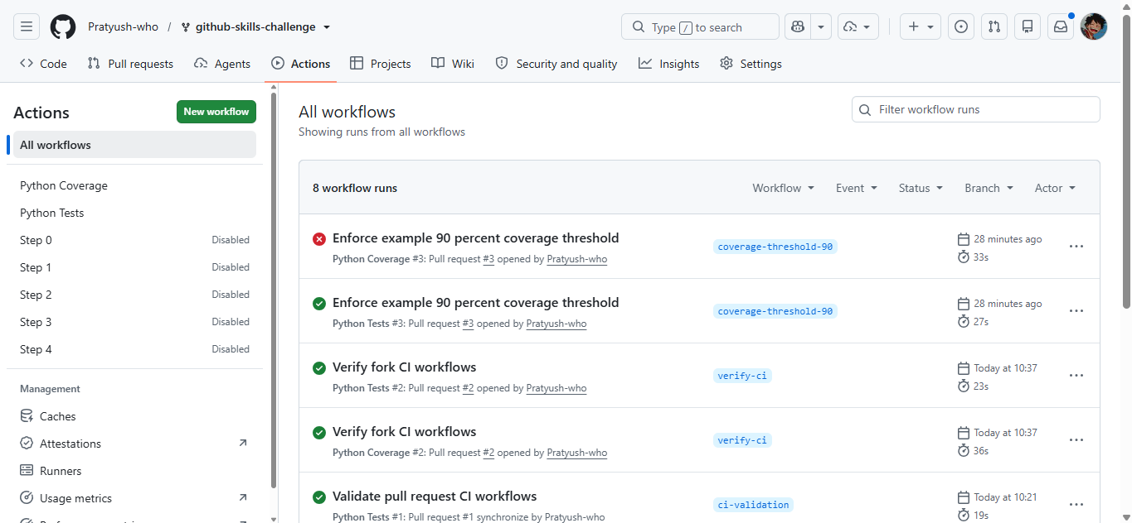

Screenshot of success test workflow—
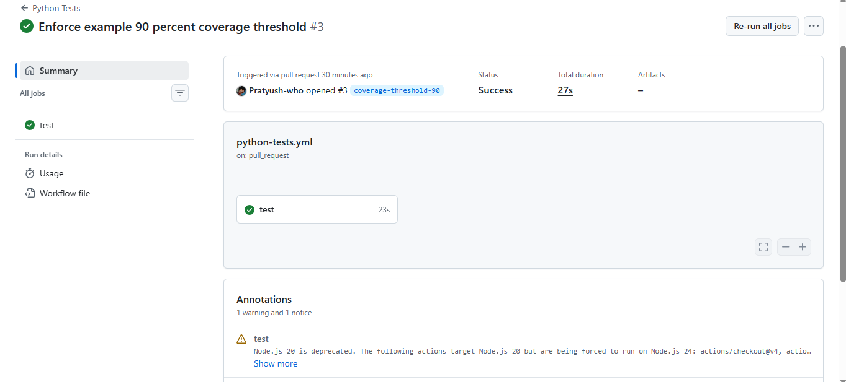

ScreenShot of Coverage one—
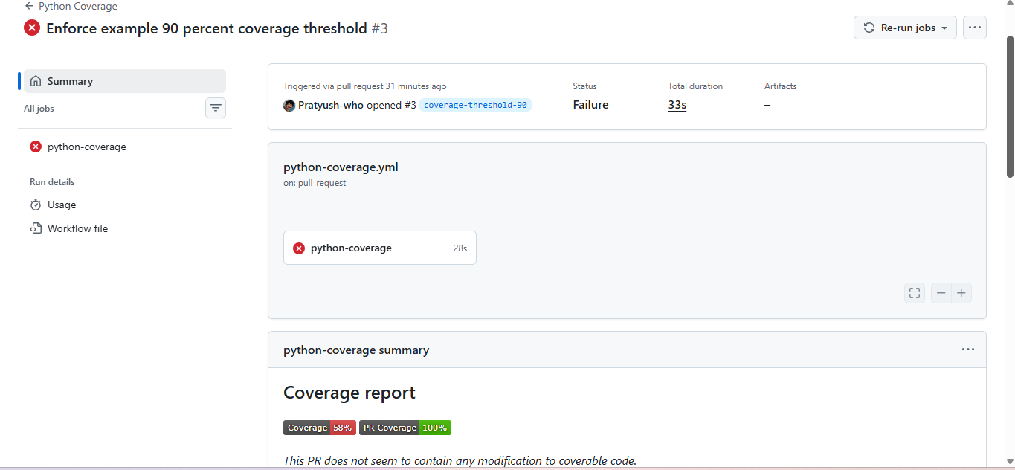
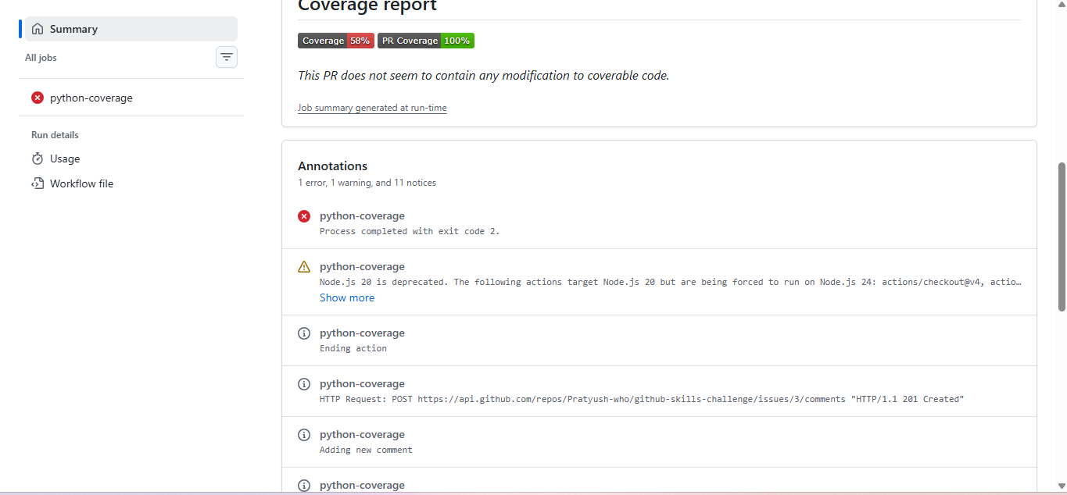
Screenshot showing the final repository/workflow files

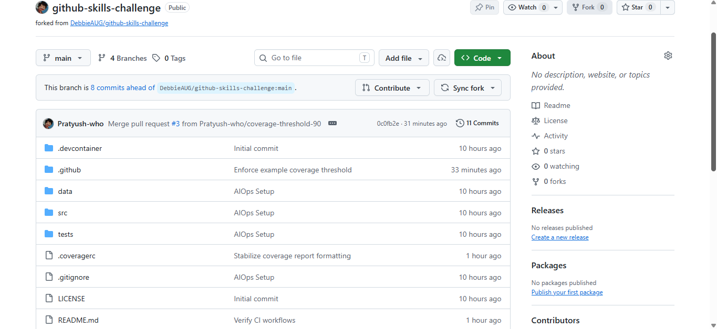

THANK YOU
-Pratyush Mehra

